**Level-6**

**Final Project**

**“Student Notice Board”**

**By**

Lovepreet Singh

Table of Contents

Project Proposal 3

Goals and Objectives 3

Project Scope 3

Project Deliverables 3

Project Specifications 4

Target Audience 4

Project Tasks and Milestones 4

Resource Requirements 5

Project Assumptions 5

Project Report 5

Detail Design 6

Home Page 6

Admin Registration Page 6

Login Page 7

Notices Page admin 7

Admin Students Page 8

Admin Notice View Page 8

Student Notices Page 8

New Student Registration Page 9

Project Testing 10

System Usability Testing 10

Testing 10

User Manual 12

System Overview 12

System Summary 12

System Configuration 12

User Access Levels 12

# 

# Project Proposal

## Goals and Objectives

Student notice board is an online web application implemented using ASP.Net. Te main goal of this application is to provide information about various announcements and special events to the registered students. In this application there is admin and student accounts. Admin has the right to register new admin for the application. Admin can add new notice, view, edit and delete the existing ones. Admin can also edit, delete and access details of various students registered with the application. Admin can also delete and access details of the notice views. Moreover, students can only view notices available at the application. New students can sign-up for the application for free.

## Project Scope

This is a 20 days project in which I have implemented an online web application named “Student Notice Board”. The scope of this project is to help student to find useful notices at time.

## Project Deliverables

Following table states the deliverables for the project:

|  |  |
| --- | --- |
| **Deliverable** | **Description** |
| Final Report | Introduces the plan and elaborates the specifications and criteria, as well as presents the goal, timeline, code and other important details. |
| Coding | This will be the project's executable code. |
| Documentation | This will demonstrate how the web application can be used. |
| Testing | This will provide the project's test details |

## Project Specifications

* Add, view, delete and edit notices.
* Admin can edit, delete and access details of students.
* Admin can delete and access details of notice views.
* Students can view notices.
* New students can sign-up for the application.

## Target Audience

Students who are willing to keep themselves up to date what is going around them will be the target audience for this application. The age can be 7 plus to 20 or more.

## Project Tasks and Milestones

Here are the tasks and milestones of the project:

|  |  |  |  |  |  |  |  |  |  |  |  |  |  |  |  |
| --- | --- | --- | --- | --- | --- | --- | --- | --- | --- | --- | --- | --- | --- | --- | --- |
| **Stages** | **Activities** | **Week1-2** | | | | **Week-2-3** | | | | | **Week-3-4** | | | | |
| Planning | **Technological analysis and brainstorming** |  |  |  |  |  |  |  |  |  |  |  |  |  |  |
| **Initial Meeting** |  |  |  |  |  |  |  |  |  |  |  |  |  |  |
| **Project Proposal** |  |  |  |  |  |  |  |  |  |  |  |  |  |  |
| Implementation | **Database Design** |  |  |  |  |  |  |  |  |  |  |  |  |  |  |
| **UI Design** |  |  |  |  |  |  |  |  |  |  |  |  |  |  |
| **Identity Framework Implementation** |  |  |  |  |  |  |  |  |  |  |  |  |  |  |
| **UI Implementation** |  |  |  |  |  |  |  |  |  |  |  |  |  |  |
| **Admin Interface Implementation** |  |  |  |  |  |  |  |  |  |  |  |  |  |  |
| **User interface Implementation** |  |  |  |  |  |  |  |  |  |  |  |  |  |  |
| **Testing** |  |  |  |  |  |  |  |  |  |  |  |  |  |  |
| Closing | **Final Documentation** |  |  |  |  |  |  |  |  |  |  |  |  |  |  |

## Resource Requirements

Following technologies and development method:

* Asp.net MVC Framework
* Microsoft word for documentation.
* Identity framework- ASP
* Windows Operating System
* 64-bit Processor and 8 GB or more RAM

## Project Assumptions

* One student and one admin will be registered by default.
* Application will be open source.

# Project Report

#### Functional Requirements

The functional requirements of this project are divided into types. One for Admin, and one for student.

|  |  |
| --- | --- |
| **Users** | **Functional Requirements** |
| **Admin** | * Add new notice, view, edit and delete the existing ones * Admin can edit, delete and access details of students. * Admin can delete and access details of the notice view. |
| **Student** | * Can view the available notices. * New students can sign-up for free. |

#### Non-Functional Requirements

|  |  |
| --- | --- |
| **Operational** | * The app should be able to run on all browsers and devices. |
| **Performance** | * Aiming to have 99% performance uptime. |
| **Security** | * Only Admin have full access to the system. |

## Detail Design

### Home Page

This is the main landing page of the application. This page contains 5 main navigation buttons – Home, Notices, Student Registration, Login and Register Notice Admin. 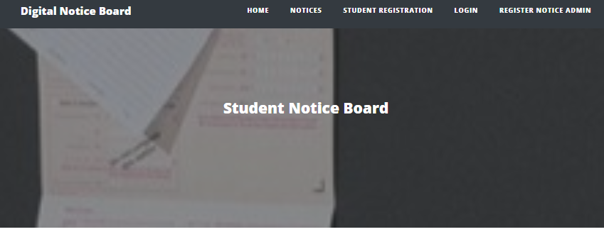

### Admin Registration Page

An Admin can register another admin by using the register page.

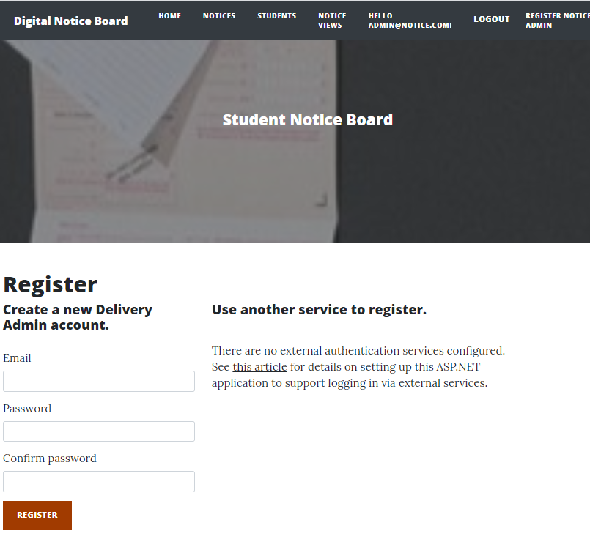

### Login Page

With the help of this page, admin and students can login to the application by using their credentials.

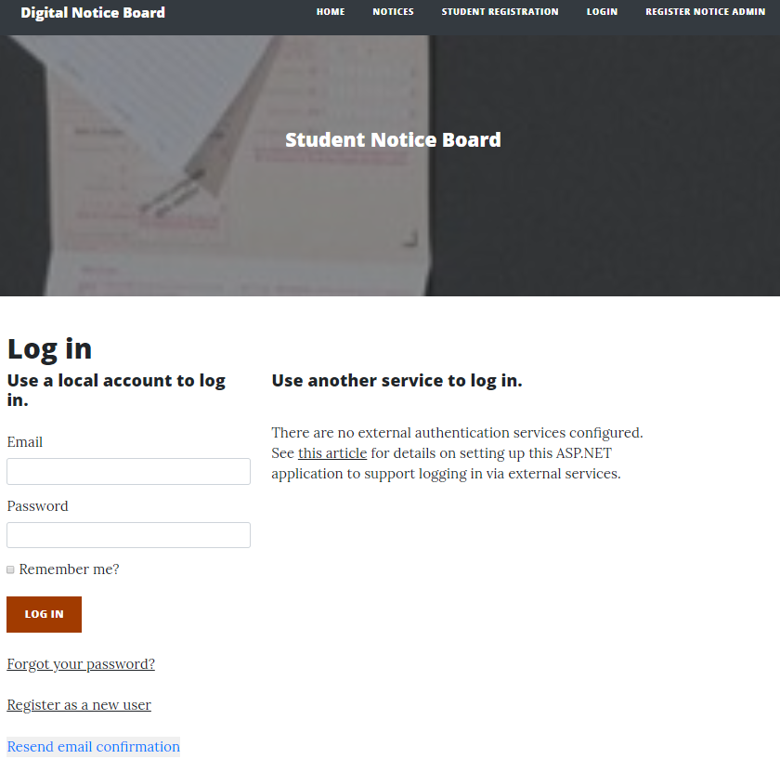

### Notices Page admin

With the help of this page, admin can add new notices, edit, delete and view the details existing ones.

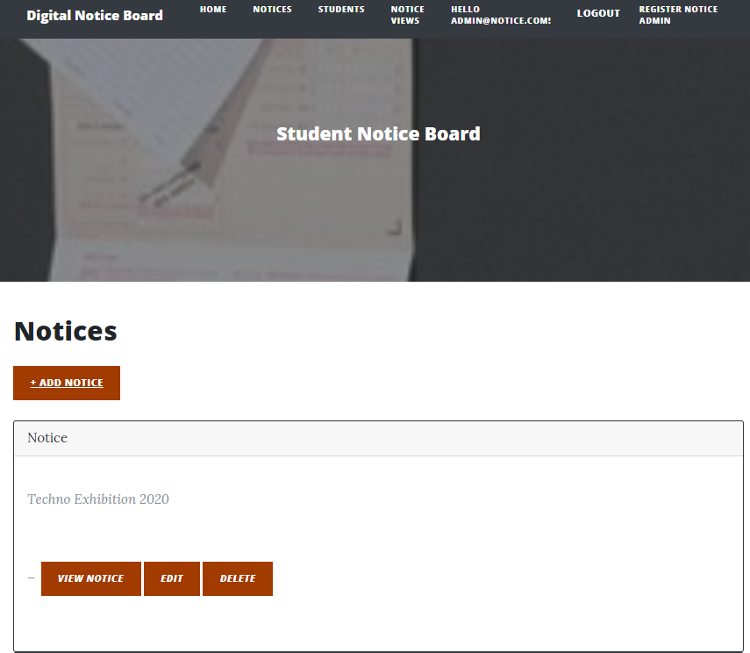

### Admin Students Page

With the help of this page, admin can edit, delete and view details of the students.

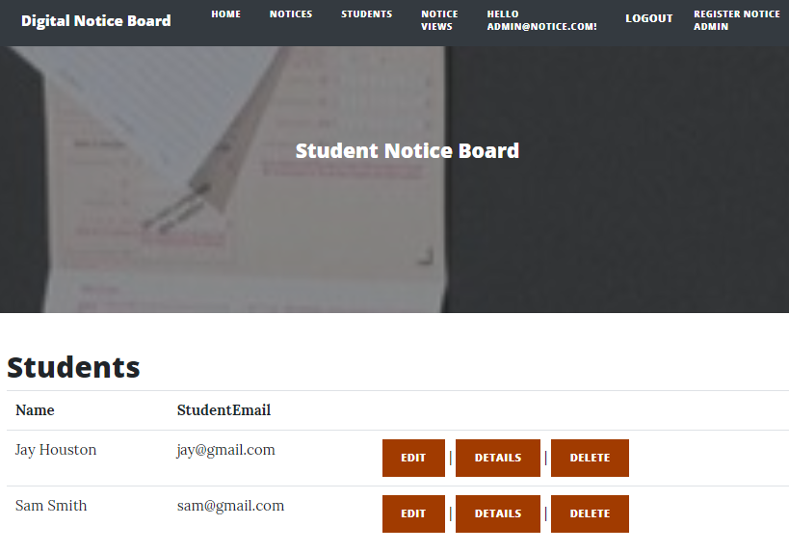

### Admin Notice View Page

This page will show rights of admin on Notice views. An admin can delete and see the details of the notices.

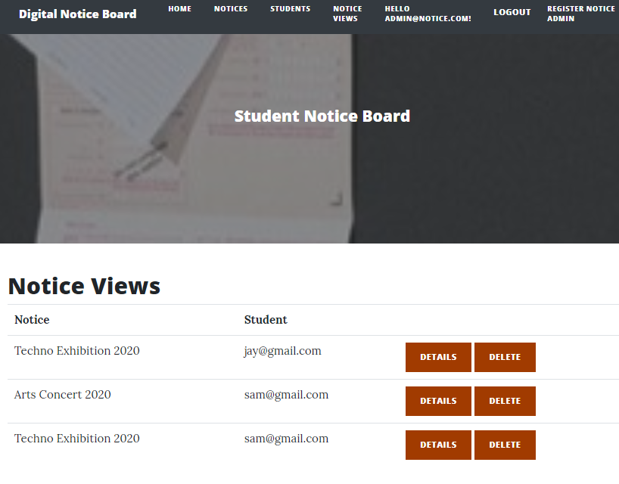

### Student Notices Page

With the help of this page, registered students can view the available notices.

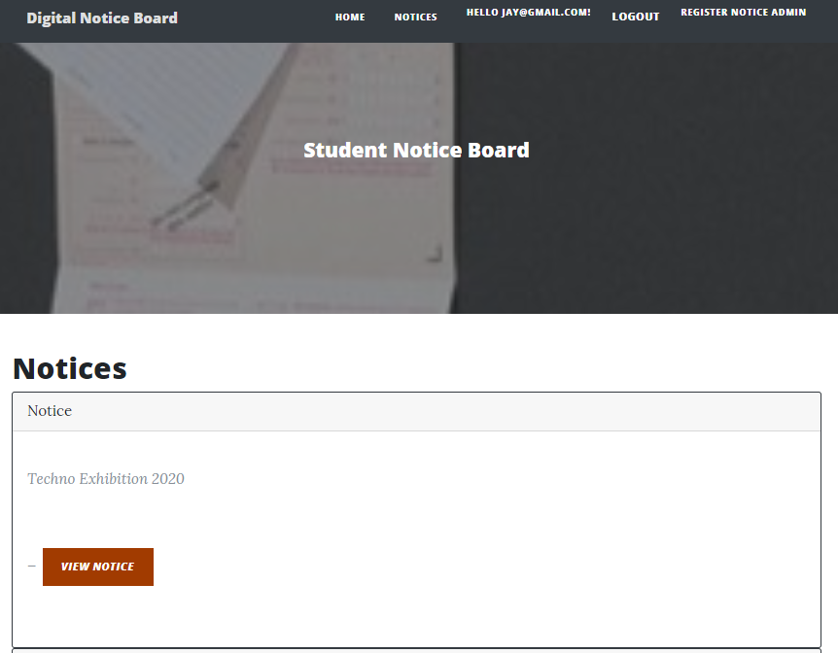

### New Student Registration Page

With the help of this page new students can register with the application.

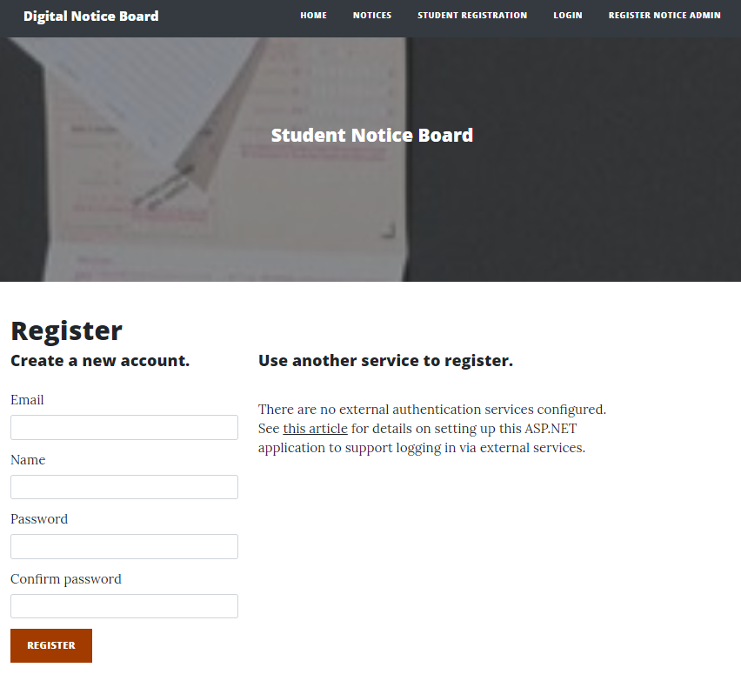

# Project Testing

## System Usability Testing

### Testing

**Tester 1**

|  |  |  |  |  |  |
| --- | --- | --- | --- | --- | --- |
| **Tester – 1** | | **Scale** | | | |
| **No.** | **Question** | **Strongly Agree** | **Agree** | **Neutral** | **Disagree** |
| 1 | I think that I would like to use this application more frequently |  |  |  |  |
| 2 | I found the system complicated |  |  |  |  |
| 3 | Is system easy to use? |  |  |  |  |
| 4 | Do you think you need the support of a technical person to use this system? |  |  |  |  |
| 5 | All functions of the system were well integrated |  |  |  |  |
| 6 | Did you find any inconsistencies in this system |  |  |  |  |
| 7 | I think most people would learn to use this system very quickly |  |  |  |  |
| 8 | I found the system very challenging to use |  |  |  |  |
| 9 | I felt very confident using the system |  |  |  |  |
| 10 | I needed to learn a lot of things before using the system |  |  |  |  |

**Tester 2**

|  |  |  |  |  |  |
| --- | --- | --- | --- | --- | --- |
| **Tester -2** | | **Scale** | | | |
| **No.** | **Question** | **Strongly Agree** | **Agree** | **Neutral** | **Disagree** |
| 1 | I think that I would like to use this application more frequently |  |  |  |  |
| 2 | I found the system complicated |  |  |  |  |
| 3 | Is system easy to use? |  |  |  |  |
| 4 | Do you think you need the support of a technical person to use this system? |  |  |  |  |
| 5 | All functions of the system were well integrated |  |  |  |  |
| 6 | Did you find any inconsistencies in this system |  |  |  |  |
| 7 | I think most people would learn to use this system very quickly |  |  |  |  |
| 8 | I found the system very challenging to use |  |  |  |  |
| 9 | I felt very confident using the system |  |  |  |  |
| 10 | I needed to learn a lot of things before using the system |  |  |  |  |

# User Manual

### System Overview

Student notice board is an online web application implemented using ASP.Net. Te main goal of this application is to provide information about various announcements and special events to the registered students. In this application there is admin and student accounts. Admin has the right to register new admin for the application. Admin can add new notice, view, edit and delete the existing ones. Admin can also edit, delete and access details of various students registered with the application. Admin can also delete and access details of the notice views. Moreover, students can only view notices available at the application. New students can sign-up for the application for free.

## System Summary

### System Configuration

Student Notice Board is a web application developed using Asp.net MVC Framework. It works on most modern web browsers and does not need a special programme setup. Internet access is required as a web application.

### User Access Levels

Only registered customers can access the features of Student Notice board web application.

**Admin:** Full access to the notices, students and notice views.

**Students:** Limited access can only see the available notices.